1. Navigate to GCS\code\CommProtocol. If there is a build folder delete it and create a new one. 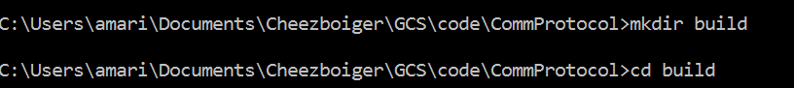
   1. If cmake is not recognized, you have to build the path from the program file
   2. <http://stackoverflow.com/questions/19176029/cmake-is-not-recognised-as-an-internal-or-external-command>

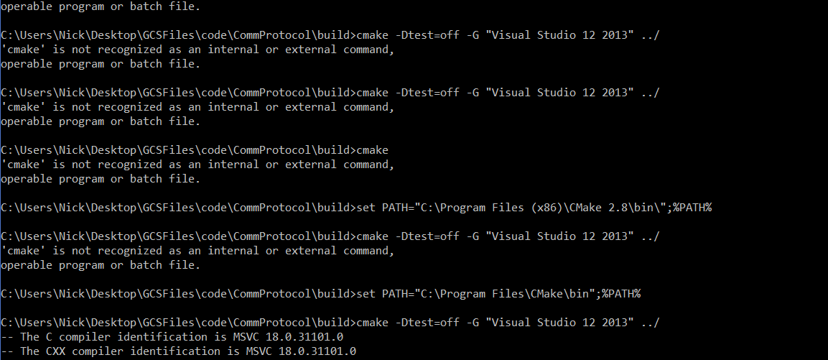

1. Run the following cmake command inside the new build folder. 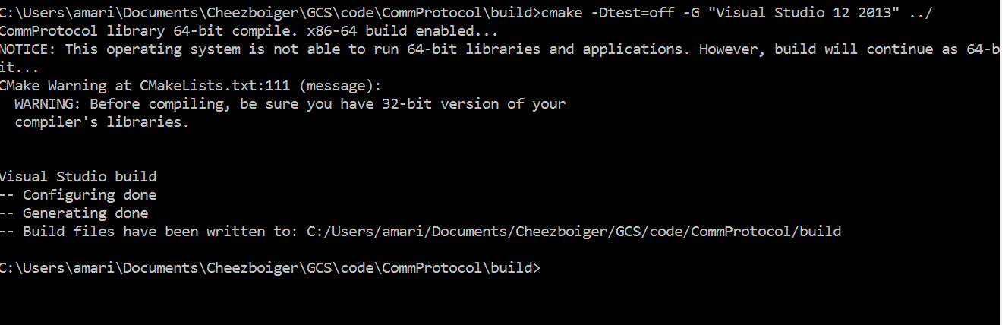
2. Go to the folder and open “CommProtocol” with Visual Studio 2013.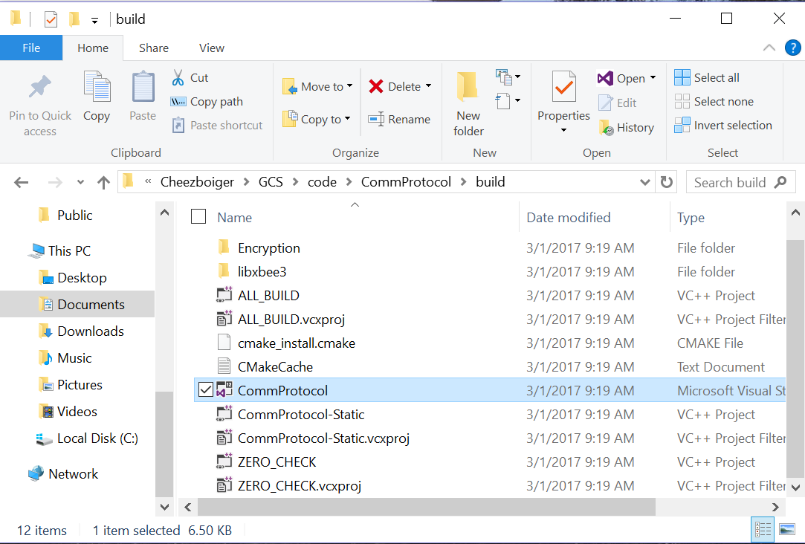
3. Go to Build > Build Solution 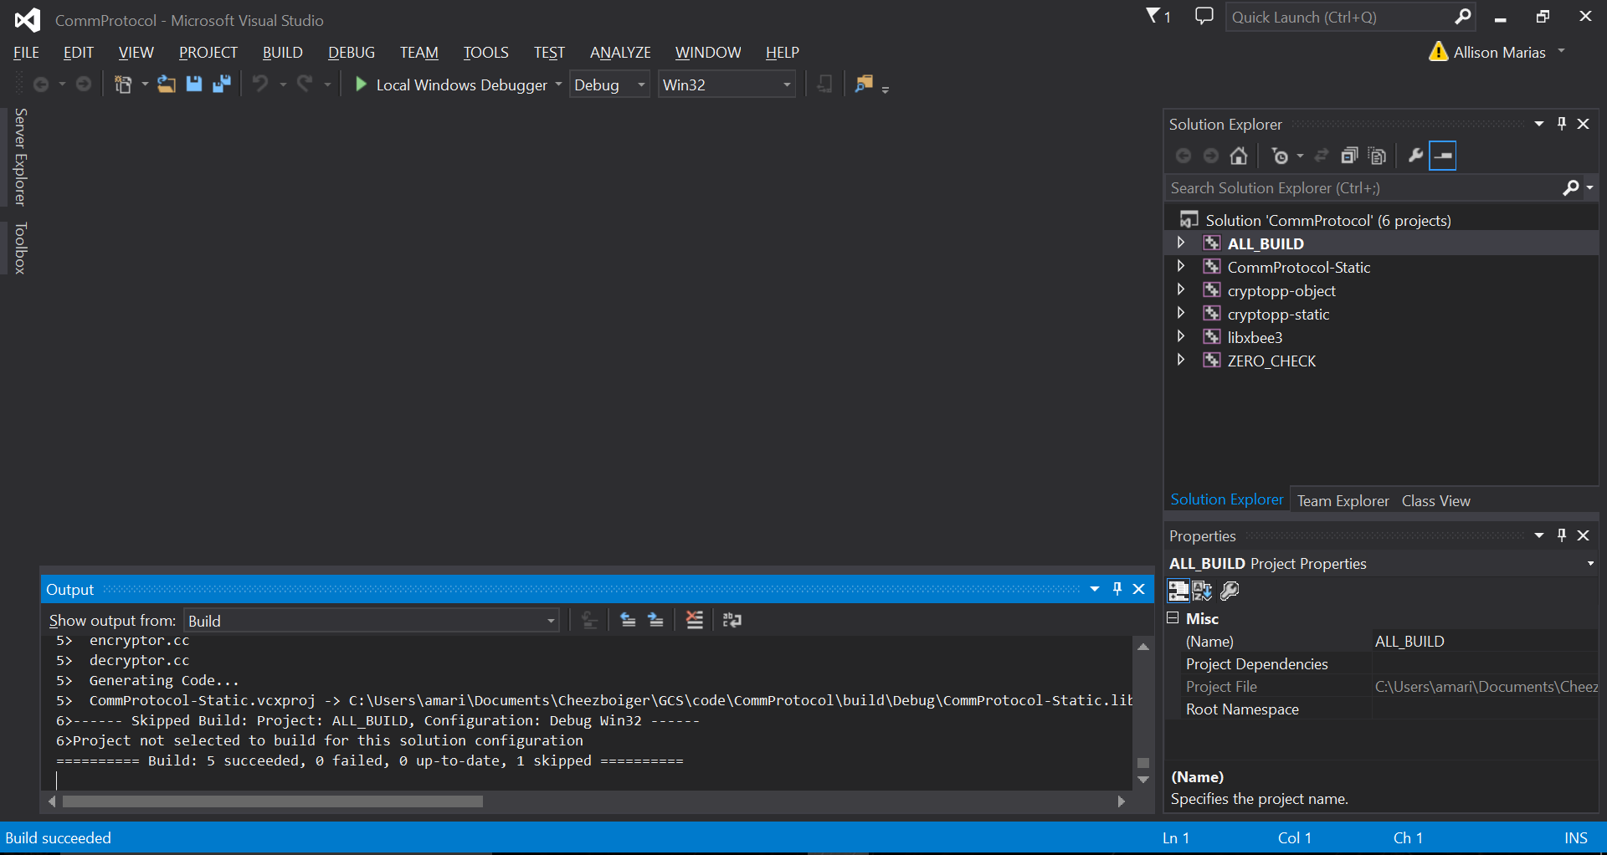
4. Open GCS on QT and go to Build > Run qmake